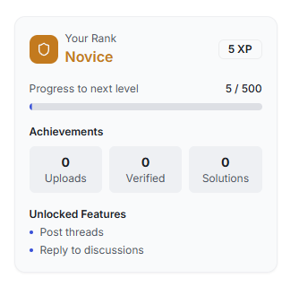

**we have to add , a article with link , oping new page showing how user can level up and also i**mporve the UI make the ui compact , more informative professional , simple, any thing relvevant ,

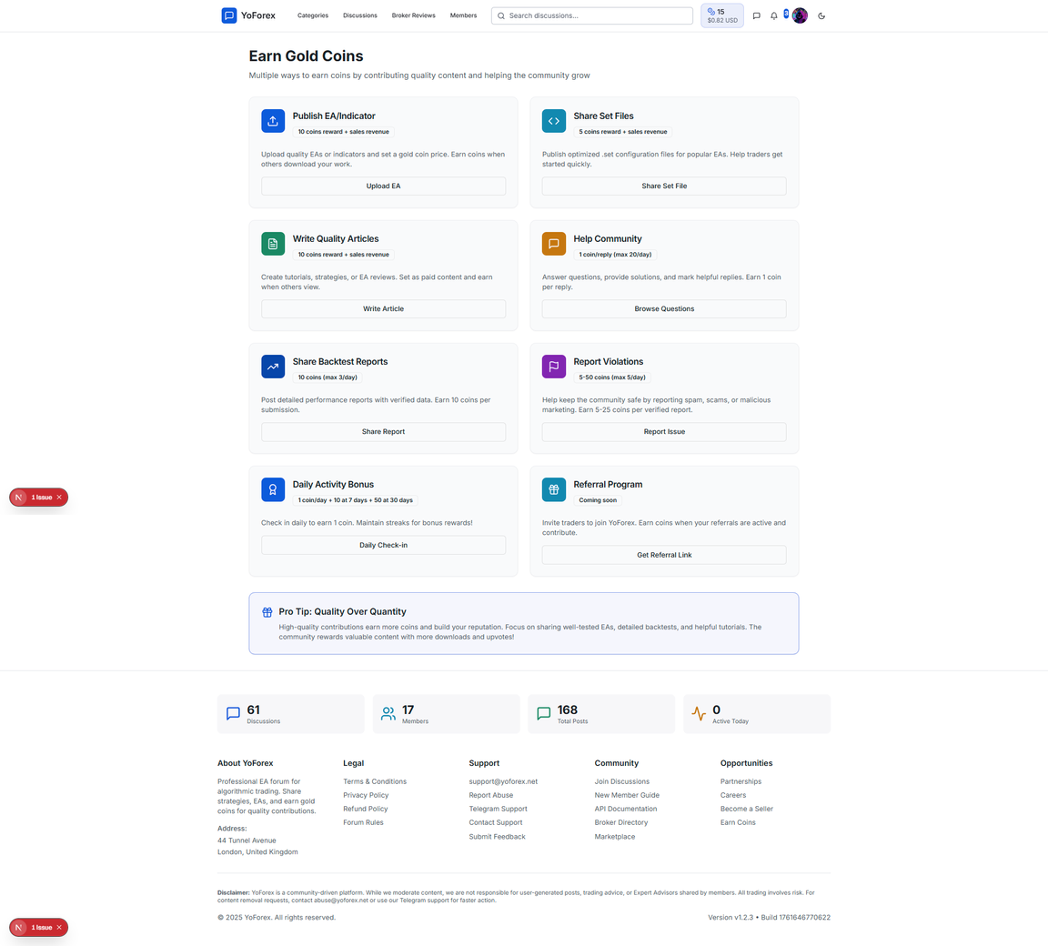

we have to improve the UI and made it user friednly and easy to understand and simple understandble , instead of giving buttons add links of articles that how user can earn explain them if you want you can create images for that articles too and link them and make sure you route properly and if you want you can share the links

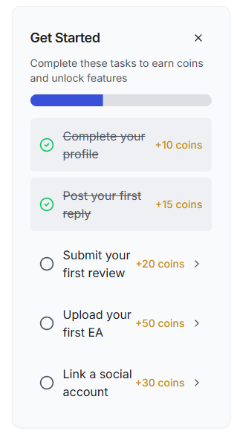

imporve the UI make the ui compact , more informative professional , simple, any thing relvevant ,

3a31727ca5346106a2cf1dc14e99e404.png

notification not working in homepage

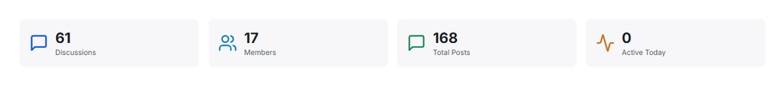

**We have to remove this from the footer, this is showing in all pages**

✅ **The stats have been successfully removed from the footer.**



Active Information

✅ **The stats have been successfully**

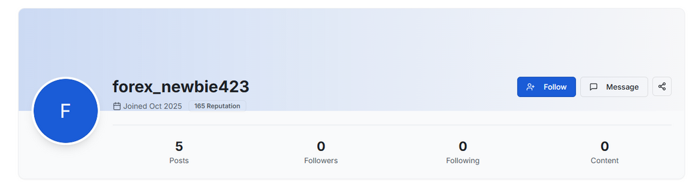

/user/[id] : User information UI is not proper and needs modification

✅ Fixed the API to calculate real counts

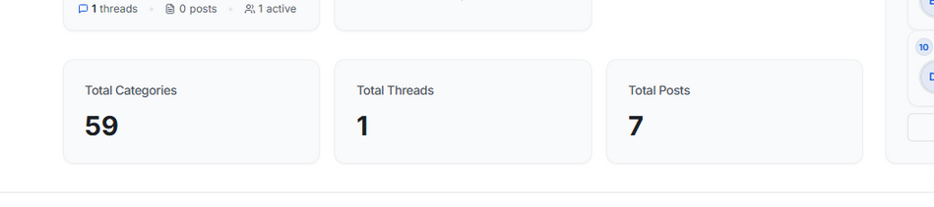

/categories: This should be on top of the page

✅ **The stats are now at the top of the page!**

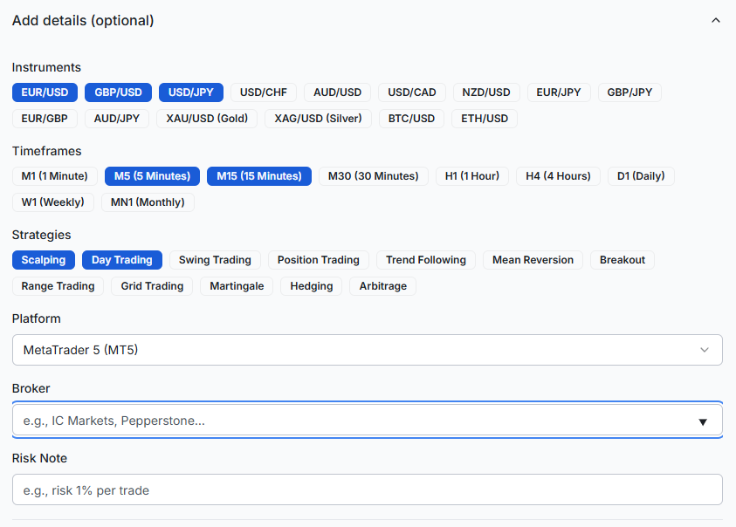

/discussions/new?category=[selected_category] : Here the all the brokers should be shown as dropdown, if selected Other, then user can give a new broker, if given it will stored in the database

Change broker selection to dropdown list ✅

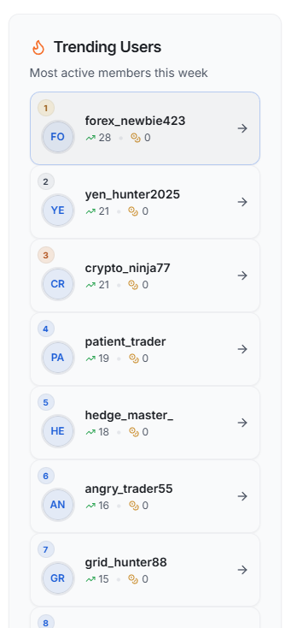

/categories: spacing needed between the user cards

Add space between trending user cards✅

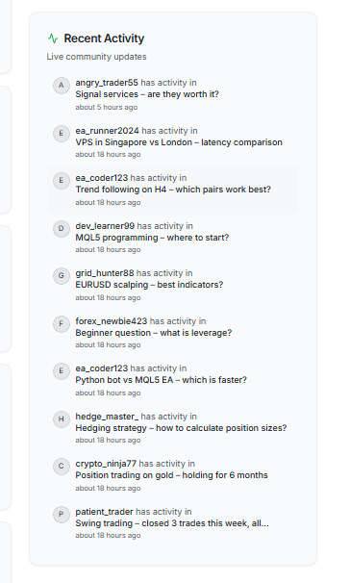

/categories: Community Update UI not found

Fix error showing no activity found✅

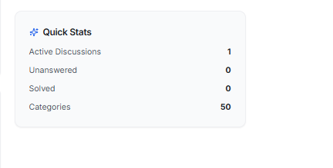

/categories: this should be the first component of last grid

found✅

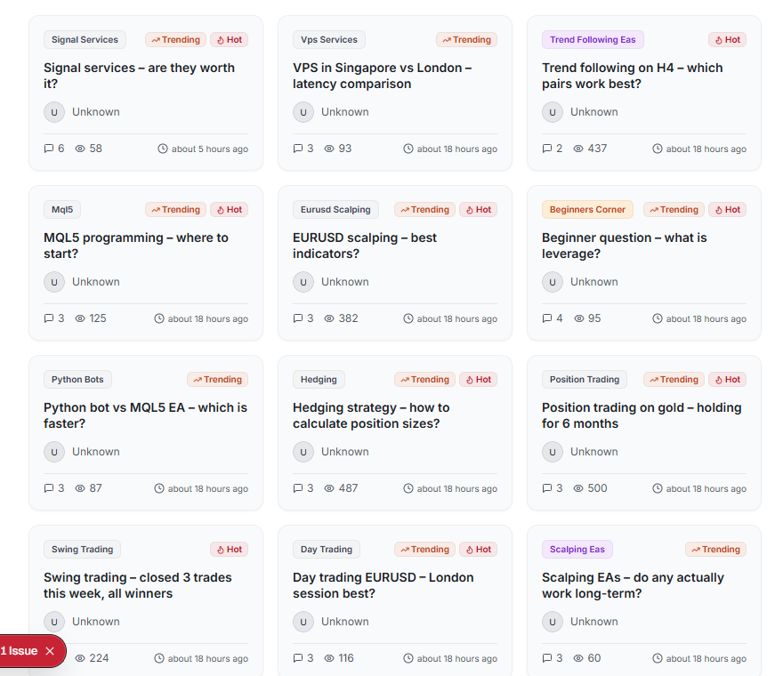

/discussions: Implement “Show more” functionality in cards display to avoid unnecessary UI height stretch

/thread/[thread_name]: the thread UI is too basic, make it a bit more interactive like Medium.

/brokers: the website should fetch existing brokers’ data from Google Search API

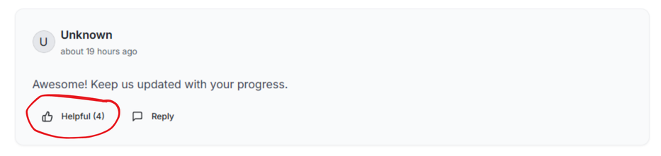

In threads’ comment, one user can give helpful like one time only, but this is not happening. The helpful onClick function is linked to a number variable, instead of boolean

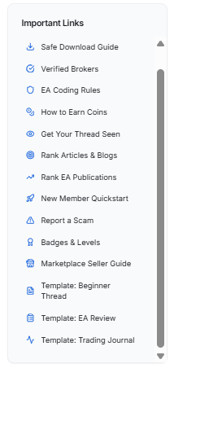

No Link 404